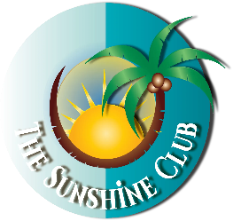
FOR IMMEDIATE RELEASE
Contact:
Alicia Figueras-Lambert
Phone: (631) 741-5616
Email: oursunshineclub@gmail.com
Website: oursunshineclub.com

The Sunshine Club: 24 Years of Bringing Joy, Connection, and Community to Orlando’s 50+ Crowd
ORLANDO, FL — For over two decades, The Sunshine Club, founded at the Downtown YMCA, has served as a vibrant social hub for the 50+ community in Orlando. Established in 2002 by the late Cecelia Figueras, a beloved Physician Assistant, the club was born from a simple but powerful observation: seniors needed more than physical fitness — they needed social connection.
“Too many seniors would come in, work out, and go home alone,” said Cecelia. “I knew that wasn’t enough to keep the spirit alive.”
Cecelia’s vision lives on through her daughter, Alicia Figueras-Lambert, who took over the leadership of The Sunshine Club in 2022. Under Alicia’s guidance, the club has expanded into four dynamic groups — including options for seniors who work during the day, groups on both the east and west sides of town, and a dedicated men’s group — all offering culturally reflective and inclusive programming.
The Sunshine Club hosts monthly luncheons or dinners, health and wellness presentations, group outings, craft and bowling clubs, an annual holiday celebration, and even a semi-annual sneaker dance party. Each event is designed to foster connection, encourage activity, and combat isolation.
“Our mission is simple,” says Alicia, “Keep seniors connected, active, and full of joy — because socialization isn’t just fun, it’s vital for mental health and well-being as we age.”
Whether you're new to Orlando or simply looking for a community of peers who believe in living life to the fullest, The Sunshine Club welcomes all adults aged 50 and older to join the fun.
For more information or to get involved, visit oursunshineclub.com or contact Alicia at
(631) 741-5616 or oursunshineclub@gmail.com.

